WEEK-2
MODULE 6 – 1.SPRING DATA JPA AND HIBERNATE HANDSON

NAME : SUDARMANI V
SUPERSET ID : 6737805

1. Explain the need and benefit of ORM
ORM:
ORM stands for Object-Relational Mapping, a technique that connects the object-oriented paradigm of languages like Java with relational databases. Rather than crafting SQL queries manually, developers work directly with objects, allowing for clearer and more maintainable code.
Benefits of ORM:
- Eliminates repetitive JDBC and SQL boilerplate.
- Automatically binds classes and tables, simplifying data persistence.
- Enables easier switching between databases (e.g., migrating from Oracle to PostgreSQL).
- Offers advanced capabilities such as caching, lazy loading, and transaction support.
- Improves security by using parameterized statements to prevent SQL injection.
Drawbacks:
- Can introduce some performance overhead.
- May obscure the expressive power of raw SQL.
- queries occasionally still require native SQL or JPQL.

2. Demonstrate the need and benefit of Spring Data JPA
Spring Data JPA:
Spring Data JPA is part of the broader Spring framework and builds upon JPA and Hibernate to simplify data access layers in Java applications.
Evolution:
- Initially, Hibernate mappings were specified using XML files.
- Later, annotations like @Entity and @Id streamlined configuration.
- Spring Data JPA further reduced effort by providing ready-made repository interfaces.
Benefits of Spring Data JPA:
- Minimizes repetitive code by offering interfaces like JpaRepository.
- Supports automatic CRUD operations and query derivation from method names.
- Integrates seamlessly with Spring Boot and related Spring components.
- Works well with in-memory databases (H2) for development and tests.

3. Explain about core objects of hibernate framework
Hibernate, a widely adopted ORM solution, is built around several important core objects:
- SessionFactory: A heavyweight, thread-safe factory for producing Session instances. Created once and reused across the application.
- Session: A lightweight, single-threaded object handling CRUD interactions with the database.
- Transaction: Manages transaction boundaries including commits and rollbacks.
- Connection Provider: Supplies JDBC connections to Hibernate internally.
- TransactionFactory: Defines strategies to create and manage transactions.
Together, these elements abstract data persistence, letting developers focus on domain logic.

4. Explain ORM implementation with Hibernate XML Configuration and Annotation Configuration
Hibernate offers two primary configuration approaches:
XML-Based Configuration:
- Define your domain model class (e.g., Employee.java).
- Create an XML mapping file (Employee.hbm.xml) to associate fields with table columns.
- Specify database connection and Hibernate settings in hibernate.cfg.xml.
- Load configuration, build a SessionFactory, and manage sessions and transactions.
Annotation-Based Configuration:
- Decorate the model class with annotations like @Entity, @Table, @Id, and @Column.
- Avoid separate mapping XMLs (though hibernate.cfg.xml is still needed for DB settings).
- This approach is more modern and commonly adopted.

Both methods follow a similar lifecycle: load configuration → open session → start transaction → persist entities → commit → close session.
5. Explain the difference between Java Persistence API, Hibernate and Spring Data JPA
- JPAJPA (Java Persistence API): A specification defining how objects should be persisted to relational databases. It only sets out interfaces and guidelines.
- Hibernate: A concrete implementation of JPA, providing additional features and the actual persistence engine.
- Spring Data JPA: An abstraction layer that builds on top of JPA (often using Hibernate internally) to further simplify repository and query development.
In short:
- JPA is the standard API.
- Hibernate is a popular provider implementing that standard.
- Spring Data JPA offers an even higher-level abstraction to speed up development.

6. Demonstrate implementation of DML using Spring Data JPA on a single database table
Spring Data JPA makes CRUD and DML operations straightforward.
Setup:
- Add Spring Boot Starter Data JPA and your database dependency (H2/MySQL).
- Define an entity class annotated with @Entity, @Id, etc.
Create a repository interface extending JpaRepository<Entity, ID>.
DML Examples:
- findById(id) → fetch a single record.
- save(entity) → insert or update a record.
- deleteById(id) → delete a record.
- findAll() → fetch all records.
- Custom queries like findByNameContaining(String name) → use query methods
Also, configure application.properties:
CopyEdit
spring.jpa.show-sql=true
spring.jpa.hibernate.ddl-auto=update
This helps with logging and schema generation.

Hands on 1 [Mandatory]:
Spring Data JPA - Quick Example :
application.properties:
spring.datasource.url=jdbc:mysql://localhost:3306/ormlearn
spring.datasource.username=root
spring.datasource.password=root
spring.datasource.driver-class-name=com.mysql.cj.jdbc.Driver

spring.jpa.hibernate.ddl-auto=validate
spring.jpa.show-sql=true
logging.level.org.hibernate.SQL=DEBUG

Country.java:
package com.cognizant.ormlearn.model;
import jakarta.persistence.Entity;
import jakarta.persistence.Id;
import jakarta.persistence.Table;

@Entity
@Table(name="country")
public class Country {

@Id
private String code;
private String name;
public Country() {
}

public String getCode() {
return code;
}
public void setCode(String code) {
this.code = code;

public String getName() {
return name;
}
public void setName(String name) {
this.name = name;
}

@Override
public String toString() {
return "Country [code=" + code + ", name=" + name + "]";
}
}

CountryRepository.java:
package com.cognizant.ormlearn.repository;
import org.springframework.data.jpa.repository.JpaRepository;
import org.springframework.stereotype.Repository;
import com.cognizant.ormlearn.model.Country;

@Repository
public interface CountryRepository
extends JpaRepository<Country, String> {

}

CountryService.java:
package com.cognizant.ormlearn.service;
import java.util.List;
import org.springframework.beans.factory.annotation.Autowired;
import org.springframework.stereotype.Service;
import com.cognizant.ormlearn.model.Country;
import com.cognizant.ormlearn.repository.CountryRepository;

@Service
public class CountryService {

@Autowired
private CountryRepository countryRepository;
public List<Country> getAllCountries() {
return countryRepository.findAll();
}
}

OrmLearnApplication.java:
package com.cognizant.ormlearn;
import java.util.List;
import org.slf4j.Logger;
import org.slf4j.LoggerFactory;
import org.springframework.boot.SpringApplication;
import org.springframework.boot.autoconfigure.SpringBootApplication;
import org.springframework.context.ApplicationContext;
import com.cognizant.ormlearn.model.Country;
import com.cognizant.ormlearn.service.CountryService;

@SpringBootApplication
public class OrmLearnApplication {

private static final Logger LOGGER =
LoggerFactory.getLogger(OrmLearnApplication.class);

private static CountryService countryService;

public static void main(String[] args) {

ApplicationContext context =
SpringApplication.run(
OrmLearnApplication.class,
args);

countryService =
context.getBean(CountryService.class);

testGetAllCountries();
LOGGER.info("Inside main");
}

private static void testGetAllCountries() {

LOGGER.info("Start");

List<Country> countries =
countryService.getAllCountries();

LOGGER.info("Countries: {}", countries);

LOGGER.info("End");
}
}

Output:

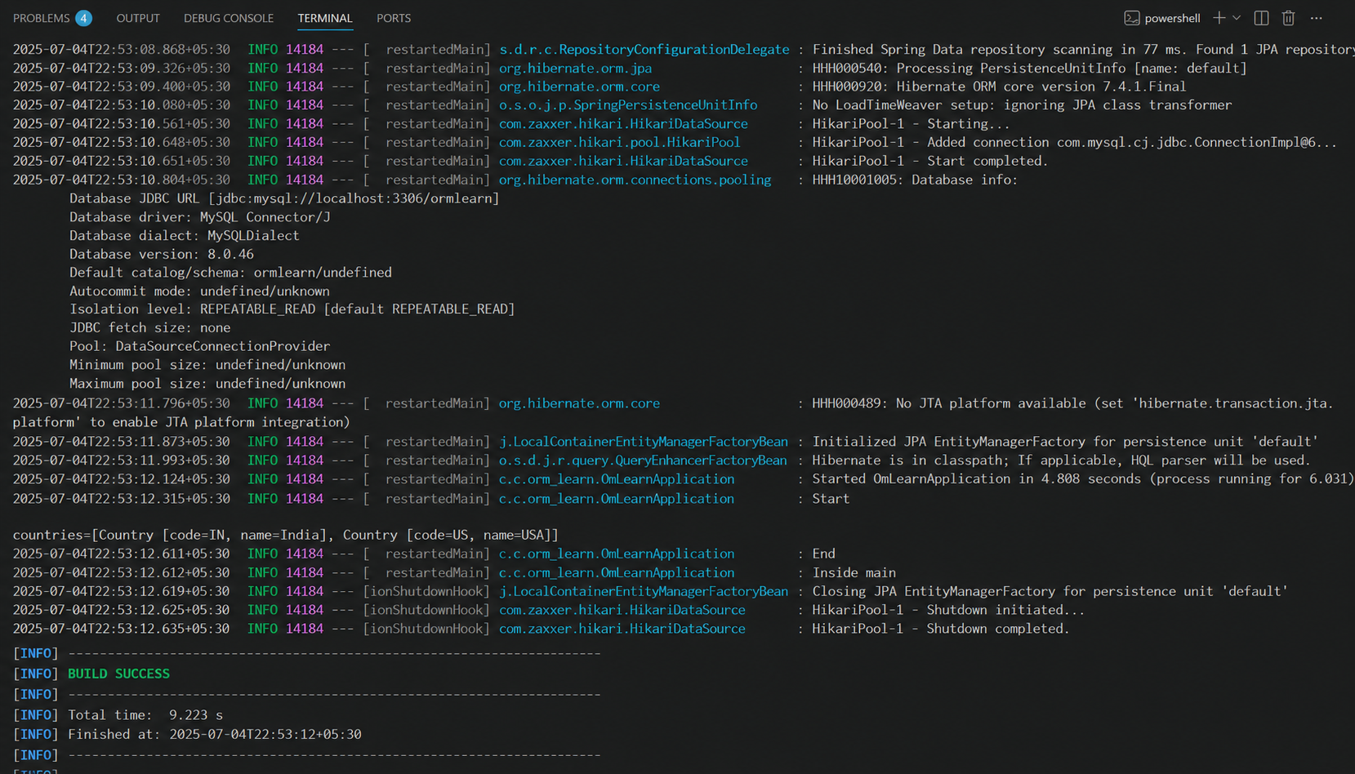

Hands on 2
Hibernate XML Config implementation walk through :
Objective
The objective of this assignment is to understand how Hibernate uses XML configuration to map Java objects with relational database tables and to perform CRUD (Create, Read, Update, Delete) operations using Hibernate APIs.

Introduction
Hibernate is an Object Relational Mapping (ORM) framework for Java. It simplifies database operations by mapping Java classes to database tables. Instead of writing SQL queries manually, developers can perform database operations using Java objects. Hibernate handles the conversion between Java objects and relational database records automatically.
The Hibernate framework mainly uses two XML configuration files:
- hibernate.cfg.xml – Contains database connection details and Hibernate properties.
- Employee.hbm.xml – Maps Java classes to database tables.

Object to Relational Database Mapping Using Hibernate XML
Hibernate performs Object Relational Mapping (ORM) through XML mapping files. Each Java class is mapped to a database table, and every class attribute is mapped to a corresponding table column.
Employee.hbm.xml
<?xml version="1.0" encoding="UTF-8"?>

<!DOCTYPE hibernate-mapping PUBLIC
"-//Hibernate/Hibernate Mapping DTD 3.0//EN"
"http://hibernate.sourceforge.net/hibernate-mapping-3.0.dtd">

<hibernate-mapping>

<class name="Employee" table="EMPLOYEE">

<id name="id" column="ID">
<generator class="native"/>
</id>

<property name="firstName" column="FIRST_NAME"/>
<property name="lastName" column="LAST_NAME"/>
<property name="salary" column="SALARY"/>

</class>

</hibernate-mapping>
Mapping Explanation
Java Class Field | Database Column
id | ID
firstName | FIRST_NAME
lastName | LAST_NAME
salary | SALARY
This mapping file tells Hibernate how each object property corresponds to a database column.

Hibernate Configuration File (hibernate.cfg.xml)
The hibernate.cfg.xml file stores database connection information and registers the mapping file.
<?xml version="1.0" encoding="UTF-8"?>

<!DOCTYPE hibernate-configuration PUBLIC
"-//Hibernate/Hibernate Configuration DTD 3.0//EN"
"http://hibernate.sourceforge.net/hibernate-configuration-3.0.dtd">

<hibernate-configuration>

<session-factory>

<property name="hibernate.connection.driver_class">
com.mysql.cj.jdbc.Driver
</property>

<property name="hibernate.connection.url">
jdbc:mysql://localhost:3306/test
</property>
<property name="hibernate.connection.username">
root
</property>
<property name="hibernate.connection.password">
root
</property>
<mapping resource="Employee.hbm.xml"/>
</session-factory>
</hibernate-configuration>
This configuration file establishes the connection between the Hibernate application and the database.

Hibernate Components
1. SessionFactory
The SessionFactory is a heavyweight object responsible for creating Session objects. It is created only once during application startup and reused throughout the application.
Example:
SessionFactory factory =
new Configuration().configure().buildSessionFactory();
Purpose:
- Creates Session objects.
- Stores Hibernate configuration.
- Improves application performance by reusing configuration.

2. Session
A Session represents a connection between the application and the database. All CRUD operations are performed through a Session object.
Example:
Session session = factory.openSession();
Purpose:
- Opens database connection.
- Executes CRUD operations.
- Manages persistent objects.

3. Transaction
A Transaction ensures that database operations are completed safely and consistently. If an error occurs, changes can be rolled back.
Example:
Transaction tx = session.beginTransaction();

4. beginTransaction()
The beginTransaction() method starts a database transaction.
Example:
Transaction tx = session.beginTransaction();
Purpose:
- Starts a transaction.
- Groups multiple database operations together.

5. commit()
The commit() method permanently saves all changes made during the transaction.
Example:
tx.commit();
Purpose:
- Saves data to the database.
- Ends the transaction successfully.

6. rollback()
The rollback() method cancels all changes if an exception occurs.
Example:
tx.rollback();
Purpose:
- Restores the database to its previous state.
- Prevents inconsistent data.

CRUD Operations in Hibernate
1. session.save()
The save() method inserts a new object into the database.
Example:
Employee emp = new Employee();

emp.setFirstName("Ananth");
emp.setLastName("Karthik");
emp.setSalary(50000);

session.save(emp);
Result: A new employee record is inserted into the EMPLOYEE table.

2. session.createQuery().list()
The createQuery().list() method retrieves all records from a table.
Example:
List<Employee> employees =
session.createQuery("FROM Employee").list();
Equivalent SQL:
SELECT * FROM EMPLOYEE;
Purpose:
- Fetches all employee records.
- Returns a List of Employee objects.

3. session.get()
The get() method retrieves a single object using its primary key.
Example:
Employee emp = session.get(Employee.class, 1);
Equivalent SQL:
SELECT * FROM EMPLOYEE WHERE ID = 1;
Purpose:
- Retrieves one specific employee.
- Returns null if the record does not exist.

4. session.delete()
The delete() method removes an object from the database.
Example:
Employee emp = session.get(Employee.class, 1);

session.delete(emp);
Equivalent SQL:
DELETE FROM EMPLOYEE WHERE ID = 1;
Purpose:
- Deletes an employee record permanently.

Complete Hibernate Execution Flow
- Configure Hibernate using hibernate.cfg.xml.
- Create a SessionFactory.
- Open a Session.
- Begin a Transaction.
- Perform CRUD operations using Session methods.
- Commit the transaction.
- Close the Session.
- Close the SessionFactory when the application ends.

Advantages of Hibernate
- Reduces the amount of JDBC code.
- Supports Object Relational Mapping (ORM).
- Database-independent framework.
- Provides automatic table mapping.
- Supports transaction management.
- Improves application maintainability and scalability.
- Offers built-in caching for better performance.

Conclusion
Hibernate XML configuration provides an efficient way to map Java objects with relational database tables. Using configuration and mapping XML files, Hibernate automatically manages database interactions. Components such as SessionFactory, Session, and Transaction work together to perform CRUD operations efficiently while ensuring data consistency and reducing development effort.

Hands on 3
Hibernate Annotation Config implementation walk through:
Objective
The objective of this assignment is to understand how Hibernate uses annotations to map Java objects to relational database tables and how Hibernate configuration is used to establish database connectivity. This assignment also explains the commonly used Hibernate annotations and their roles in object-relational mapping (ORM).

Introduction
Hibernate is a popular Object Relational Mapping (ORM) framework for Java applications. It simplifies database programming by allowing developers to work with Java objects instead of writing SQL queries manually.
Unlike XML-based mapping, Hibernate Annotations allow mapping information to be written directly inside the Java class. This approach reduces configuration complexity and makes the code easier to understand and maintain.
The mapping is done using annotations such as @Entity, @Table, @Id, @GeneratedValue, and @Column.

Object to Relational Database Mapping in Employee Persistence Class
In annotation-based Hibernate, the Java class itself contains mapping information through annotations.
Employee.java
import jakarta.persistence.*;

@Entity
@Table(name = "EMPLOYEE")
public class Employee {

@Id
@GeneratedValue(strategy = GenerationType.IDENTITY)
@Column(name = "ID")
private int id;

@Column(name = "FIRST_NAME")
private String firstName;

@Column(name = "LAST_NAME")
private String lastName;

@Column(name = "SALARY")
private int salary;

public Employee() {
}

// Getters and Setters
}

Object Relational Mapping
Java Class | Database Table
Employee | EMPLOYEE

Java Field | Database Column
id | ID
firstName | FIRST_NAME
lastName | LAST_NAME
salary | SALARY
The annotations instruct Hibernate on how each Java object and its fields correspond to the database table and columns.

Explanation of Hibernate Annotations
1. @Entity
The @Entity annotation specifies that a Java class is a Hibernate entity. An entity represents a table in the relational database.
Example:
@Entity
public class Employee {
}
Purpose
- Declares the class as a persistent entity.
- Enables Hibernate to store objects of this class in the database.

2. @Table
The @Table annotation specifies the name of the database table associated with the entity.
Example:
@Entity
@Table(name = "EMPLOYEE")
public class Employee {
}
Purpose
- Maps the Java class to a specific database table.
- If omitted, Hibernate uses the class name as the table name by default.

3. @Id
The @Id annotation marks a field as the primary key of the entity.
Example:
@Id
private int id;
Purpose
- Identifies each record uniquely.
- Required for every Hibernate entity.

4. @GeneratedValue
The @GeneratedValue annotation specifies that the primary key value should be generated automatically.
Example:
@Id
@GeneratedValue(strategy = GenerationType.IDENTITY)
private int id;
Purpose
- Automatically generates primary key values.
- Eliminates the need to assign IDs manually.
Common Generation Strategies:
- AUTO
- IDENTITY
- SEQUENCE
- TABLE

5. @Column
The @Column annotation maps a Java field to a database column.
Example:
@Column(name = "FIRST_NAME")
private String firstName;
Purpose
- Specifies the column name.
- Allows customization of column properties such as length, uniqueness, and nullability.

Hibernate Configuration (hibernate.cfg.xml)
The hibernate.cfg.xml file contains all the configuration details required for Hibernate to connect with the database.
Example Configuration
<?xml version="1.0" encoding="UTF-8"?>

<!DOCTYPE hibernate-configuration PUBLIC
"-//Hibernate/Hibernate Configuration DTD 3.0//EN"
"http://hibernate.sourceforge.net/hibernate-configuration-3.0.dtd">

<hibernate-configuration>

<session-factory>

<property name="hibernate.dialect">
org.hibernate.dialect.MySQLDialect
</property>

<property name="hibernate.connection.driver_class">
com.mysql.cj.jdbc.Driver
</property>

<property name="hibernate.connection.url">
jdbc:mysql://localhost:3306/test
</property>

<property name="hibernate.connection.username">
root
</property>

<property name="hibernate.connection.password">
root
</property>

<mapping class="Employee"/>

</session-factory>

</hibernate-configuration>
Hibernate Configuration Properties
1. Dialect
The Hibernate Dialect specifies the SQL language used by the database.
Example:
<property name="hibernate.dialect">
org.hibernate.dialect.MySQLDialect
</property>
Purpose
- Generates database-specific SQL statements.
- Supports different databases such as MySQL, Oracle, PostgreSQL, and SQL Server.

2. Driver
The Driver property specifies the JDBC driver used to connect to the database.
Example:
<property name="hibernate.connection.driver_class">
com.mysql.cj.jdbc.Driver
</property>
Purpose
- Establishes communication between Java and the database.

3. Connection URL
The Connection URL specifies the location of the database.
Example:
<property name="hibernate.connection.url">
jdbc:mysql://localhost:3306/test
</property>
Purpose
- Specifies the database server, port number, and database name.

4. Username
The Username property specifies the login username for the database.
Example:
<property name="hibernate.connection.username">
root
</property>
Purpose
- Authenticates the database user.

5. Password
The Password property specifies the password for the database user.
Example:
<property name="hibernate.connection.password">
root
</property>
Purpose
- Provides secure access to the database.

Advantages of Hibernate Annotations
- Eliminates the need for separate XML mapping files.
- Keeps mapping information within the Java class.
- Makes the application easier to maintain.
- Reduces configuration complexity.
- Improves code readability.
- Supports automatic schema generation.
- Simplifies object-relational mapping.

Conclusion
Hibernate Annotation Configuration provides a modern and efficient approach for mapping Java objects to relational database tables. By using annotations such as @Entity, @Table, @Id, @GeneratedValue, and @Column, developers can define mappings directly within the Java class. The hibernate.cfg.xml file manages database connectivity through properties such as Dialect, Driver, Connection URL, Username, and Password. Together, annotations and configuration files simplify database operations, improve code maintainability, and reduce development effort in enterprise Java applications.

Hands on 4
Difference between JPA, Hibernate and Spring Data JPA :
Country.java:
package com.cognizant.orm_learn.model;

import jakarta.persistence.Entity;
import jakarta.persistence.Id;
import jakarta.persistence.Table;

@Entity
@Table(name = "country")
public class Country {

@Id
private String code;

private String name;

public Country() {
}

public Country(String code, String name) {
this.code = code;
this.name = name;
}

public String getCode() {
return code;
}

public void setCode(String code) {
this.code = code;
}

public String getName() {
return name;
}

public void setName(String name) {
this.name = name;
}
}

CountryRepository.java:
package com.cognizant.orm_learn.repository;

import org.springframework.data.jpa.repository.JpaRepository;
import com.cognizant.orm_learn.model.Country;

public interface CountryRepository
extends JpaRepository<Country, String> {

}

CountryService.java:
package com.cognizant.orm_learn.service;

import org.springframework.beans.factory.annotation.Autowired;
import org.springframework.stereotype.Service;

import com.cognizant.orm_learn.model.Country;
import com.cognizant.orm_learn.repository.CountryRepository;

@Service
public class CountryService {

@Autowired
private CountryRepository countryRepository;

public void addCountry() {

Country country = new Country("IN", "India");

countryRepository.save(country);

System.out.println("Country inserted successfully");
}
}

OrmApplication.java:
package com.cognizant.orm_learn;
import org.springframework.beans.factory.annotation.Autowired;
import rg.springframework.boot.CommandLineRunner;
import org.springframework.boot.SpringApplication;
import org.springframework.boot.autoconfigure.SpringBootApplication;
import com.cognizant.orm_learn.service.CountryService;
@SpringBootApplication
public class OrmLearnApplication implements CommandLineRunner
@Auowired
private CountryService countryService;
public static void main(String[] args) {
SpringApplication.run(
OrmLearnApplication.class,
args
);
@Override
public void run(String... args) {
countryService.addCountry();
}
}

Console output: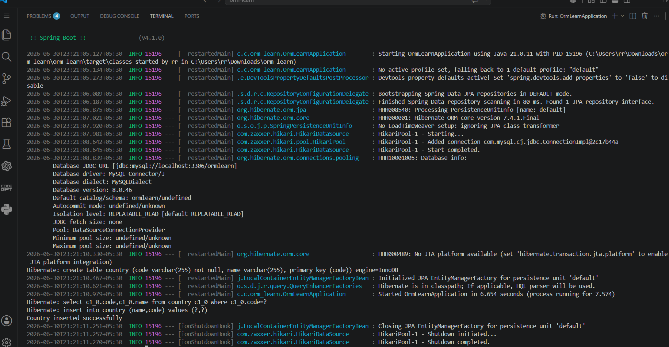
Database output:
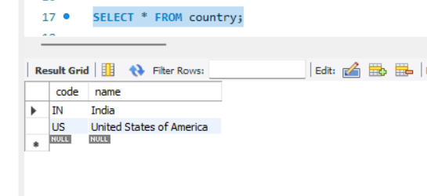

Hands on 5
Implement services for managing Country :
Country.java:
package com.cognizant.orm_learn.model;

import jakarta.persistence.Entity;
import jakarta.persistence.Id;
import jakarta.persistence.Table;

@Entity
@Table(name = "country")
public class Country {

@Id
private String code;
private String name;
public Country() {
}

public Country(String code, String name) {
this.code = code;
this.name = name;
}
public String getCode() {
return code;
}
public void setCode(String code) {
this.code = code;
}

public String getName() {
return name;
}

public void setName(String name) {
this.name = name;
}

@Override
public String toString() {
return "Country [code=" + code + ", name=" + name + "]";
}
}

CountryRepository.java:
package com.cognizant.orm_learn.repository;
import java.util.List;
import org.springframework.data.jpa.repository.JpaRepository;
import org.springframework.stereotype.Repository;
import com.cognizant.orm_learn.model.Country;

@Repository
public interface CountryRepository extends JpaRepository<Country, String> {

List<Country> findByNameContainingIgnoreCase(String name);

}

CountryService.java:
package com.cognizant.orm_learn.service;

import java.util.List;

import org.springframework.beans.factory.annotation.Autowired;
import org.springframework.stereotype.Service;

import com.cognizant.orm_learn.model.Country;
import com.cognizant.orm_learn.repository.CountryRepository;

@Service
public class CountryService {

@Autowired
private CountryRepository countryRepository;

public Country getCountry(String code) {
return countryRepository.findById(code).orElse(null);
}

public void addCountry(Country country) {
countryRepository.save(country);
System.out.println("Country added successfully");
}

public void updateCountry(Country country) {
countryRepository.save(country);
System.out.println("Country updated successfully");
}

public void deleteCountry(String code) {
countryRepository.deleteById(code);
System.out.println("Country deleted successfully");
}

public List<Country> searchCountry(String name) {
return countryRepository.findByNameContainingIgnoreCase(name);
}
}

OrmApplication.java:
package com.cognizant.orm_learn;

import org.springframework.beans.factory.annotation.Autowired;
import org.springframework.boot.CommandLineRunner;
import org.springframework.boot.SpringApplication;
import org.springframework.boot.autoconfigure.SpringBootApplication;

import com.cognizant.orm_learn.model.Country;
import com.cognizant.orm_learn.service.CountryService;

@SpringBootApplication
public class OrmLearnApplication implements CommandLineRunner {

@Autowired
private CountryService countryService;

public static void main(String[] args) {
SpringApplication.run(OrmLearnApplication.class, args);
}

@Override
public void run(String... args) {

System.out.println(countryService.getCountry("IN"));

countryService.addCountry(
new Country("NP", "Nepal"));

countryService.updateCountry(
new Country("NP", "Federal Democratic Republic of Nepal"));
countryService.deleteCountry("NP");
countryService.searchCountry("Uni")
.forEach(System.out::println);
}
}

application.properties:
spring.datasource.url=jdbc:mysql://localhost:3306/ormlearn
spring.datasource.username=root
spring.datasource.password=Naveen@2006
spring.jpa.show-sql=true
spring.jpa.hibernate.ddl-auto=update

Output:
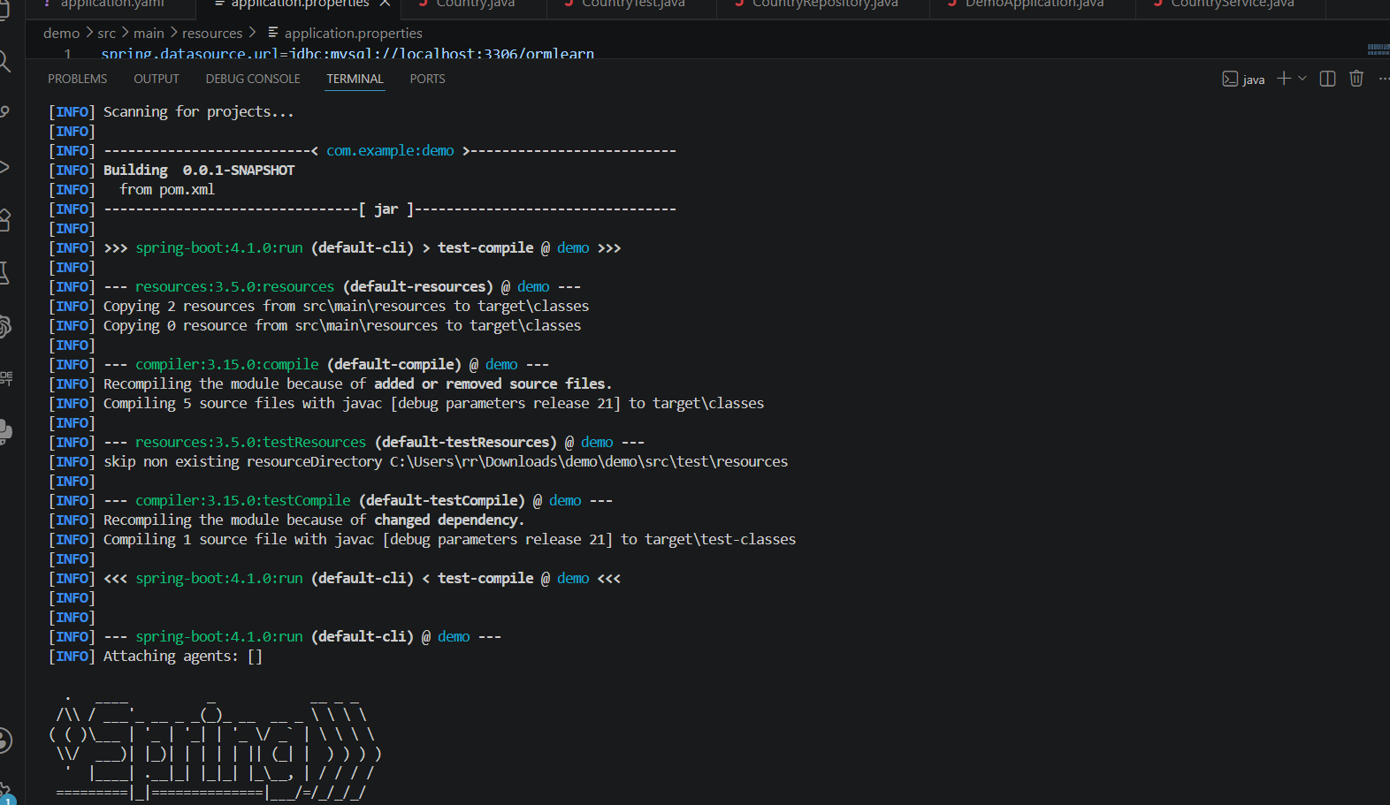

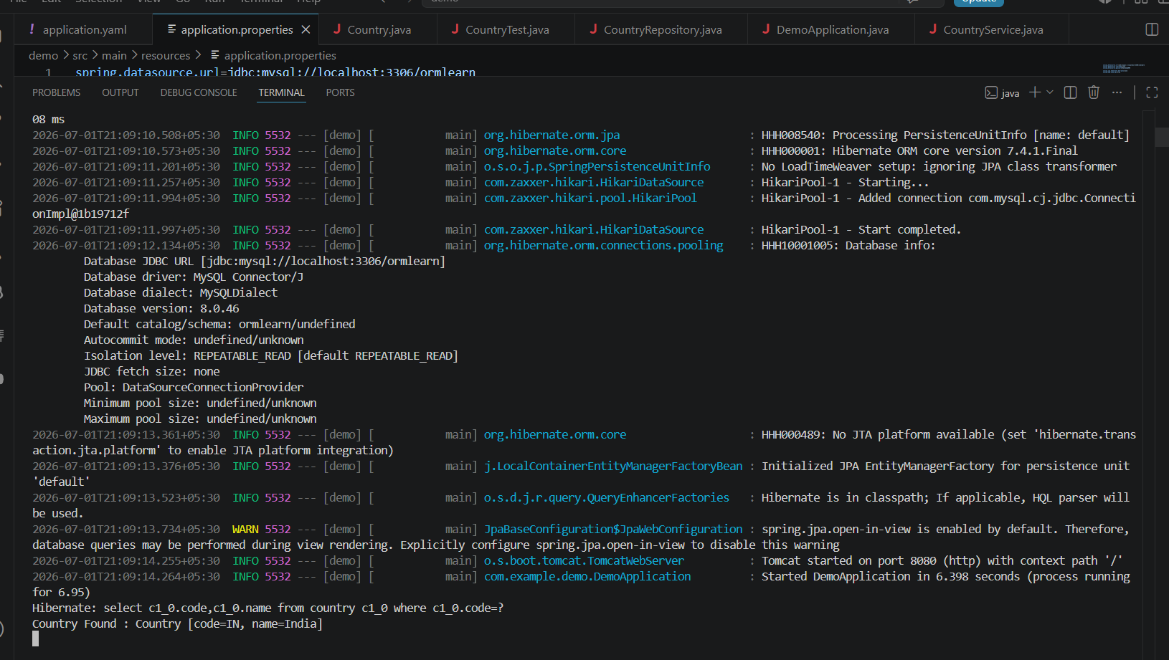
Hands on 6
Find a country based on country code :
CountryNotFoundException:
package com.example.demo.service.exception;
public class CountryNotFoundException extends Exception {

public CountryNotFoundException() {
super("Country not found");
}
}

CountryService.java:
package com.example.demo.service
import java.util.Optional;
import org.springframework.beans.factory.annotation.Autowired;
import org.springframework.stereotype.Service;
import org.springframework.transaction.annotation.Transactional;
import com.example.demo.model.Country;
import com.example.demo.repository.CountryRepository;
import com.example.demo.service.exception.CountryNotFoundException;

@Service
public class CountryService {

@Autowired
private CountryRepository countryRepository;

@Transactional
public Country findCountryByCode(String countryCode)
throws CountryNotFoundException {

Optional<Country> result =
countryRepository.findById(countryCode);

if (!result.isPresent()) {
throw new CountryNotFoundException();
}

Country country = result.get();

return country;
}
}

CountryTest.java:
package com.example.demo;

import org.springframework.beans.factory.annotation.Autowired;
import org.springframework.boot.CommandLineRunner;
import org.springframework.stereotype.Component;

import com.example.demo.model.Country;
import com.example.demo.service.CountryService;
import com.example.demo.service.exception.CountryNotFoundException;

@Component
public class CountryTest implements CommandLineRunner {

@Autowired
private CountryService countryService;

@Override
public void run(String... args) throws Exception {

getCountryTest();
}

private void getCountryTest()
throws CountryNotFoundException {
System.out.println("Start");

Country country =
countryService.findCountryByCode("IN");
System.out.println("Country : " + country);
System.out.println("End");
}
}

CountryRepository.java:
package com.example.demo.repository;
import org.springframework.data.jpa.repository.JpaRepository;
import com.example.demo.model.Country
public interface CountryRepository extends JpaRepository<Country, String> {

}

DemoApplication.java:
package com.example.demo;
import org.springframework.boot.SpringApplication;
import org.springframework.boot.autoconfigure.SpringBootApplication;

@SpringBootApplication
public class DemoApplication {
public static void main(String[] args) {
SpringApplication.run(DemoApplication.class, args);
}
}

Output:
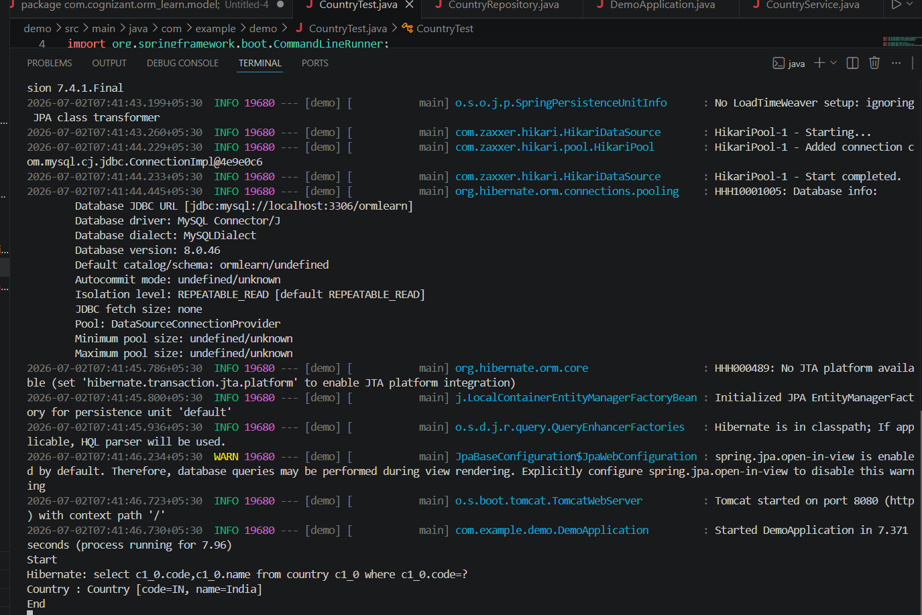
Hands on 7
Add a new country :
countryNotFoundException:

package com.example.demo.exception;
public class CountryNotFoundException extends Exception {
public CountryNotFoundException() {
super("Country not found");
}
}
Country.java:
package com.example.demo.model;

import jakarta.persistence.Entity;
import jakarta.persistence.Id;
import jakarta.persistence.Table;

@Entity
@Table(name = "country")
public class Country {

@Id
private String code;

private String name;

public Country() {
}

public Country(String code, String name) {
this.code = code;
this.name = name;
}

public String getCode() {
return code;
}

public void setCode(String code) {
this.code = code;
}

public String getName() {
return name;
}

public void setName(String name) {
this.name = name;
}

@Override
public String toString() {
return "Country [code=" + code + ", name=" + name + "]";
}
}

CountryRepository.java:
package com.example.demo.repository;

import org.springframework.data.jpa.repository.JpaRepository;

import com.example.demo.model.Country;

public interface CountryRepository extends JpaRepository<Country, String> {

}

CountryService.java:
package com.example.demo.service;
import java.util.Optional;
import org.springframework.beans.factory.annotation.Autowired;
import org.springframework.stereotype.Service;
import com.example.demo.exception.CountryNotFoundException;
import com.example.demo.model.Country;
import com.example.demo.repository.CountryRepository;
import jakarta.transaction.Transactional;

@Service
public class CountryService {

@Autowired
private CountryRepository countryRepository;

@Transactional
public Country findCountryByCode(String countryCode)
throws CountryNotFoundException {

Optional<Country> result =
countryRepository.findById(countryCode);

if (!result.isPresent()) {
throw new CountryNotFoundException();
}
return result.get();
}
@Transactional
public void addCountry(Country country) {
countryRepository.save(country);
}
}

Output:

